Report on Analysis of Customer Database of General Stores Limited

- Data Pre-processing:
The dates in the column ‘Order Date’ in the sheet ‘Orders’ were in object data type. Data type conversion is performed to make it in the Date format. Some dates were not in the right format, and those were removed using Python. The column ‘region’ was in object format, and it was transformed into a geographical role using Tableau. A new column named ‘Profit’ was created by subtracting the column ‘Cost’ from ‘Price’.

Analysis:
- The overall performance of the company since the start of 2024 up to now.

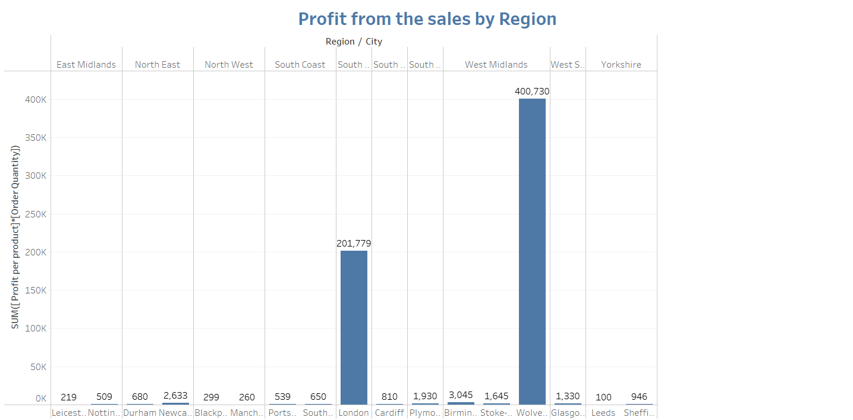
Fig 2.1

Figure 2.1 shows the cities and regions with the highest and the lowest profit for the year 2024 – 2025.

From Figure 2.2, we can see that the order quantity, profit, cost, and price have decreased from 2024 -2025. Figure 2.3 shows the change in these metrics by month.
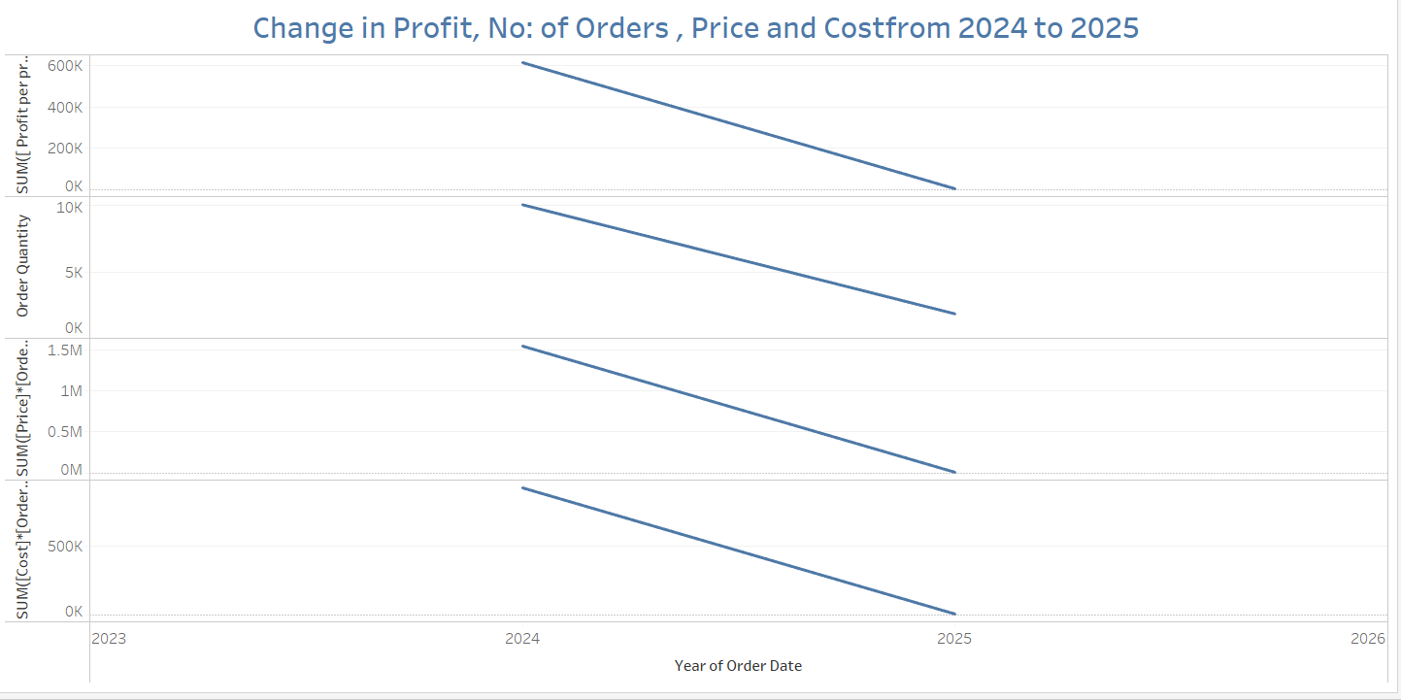
Fig 2.2

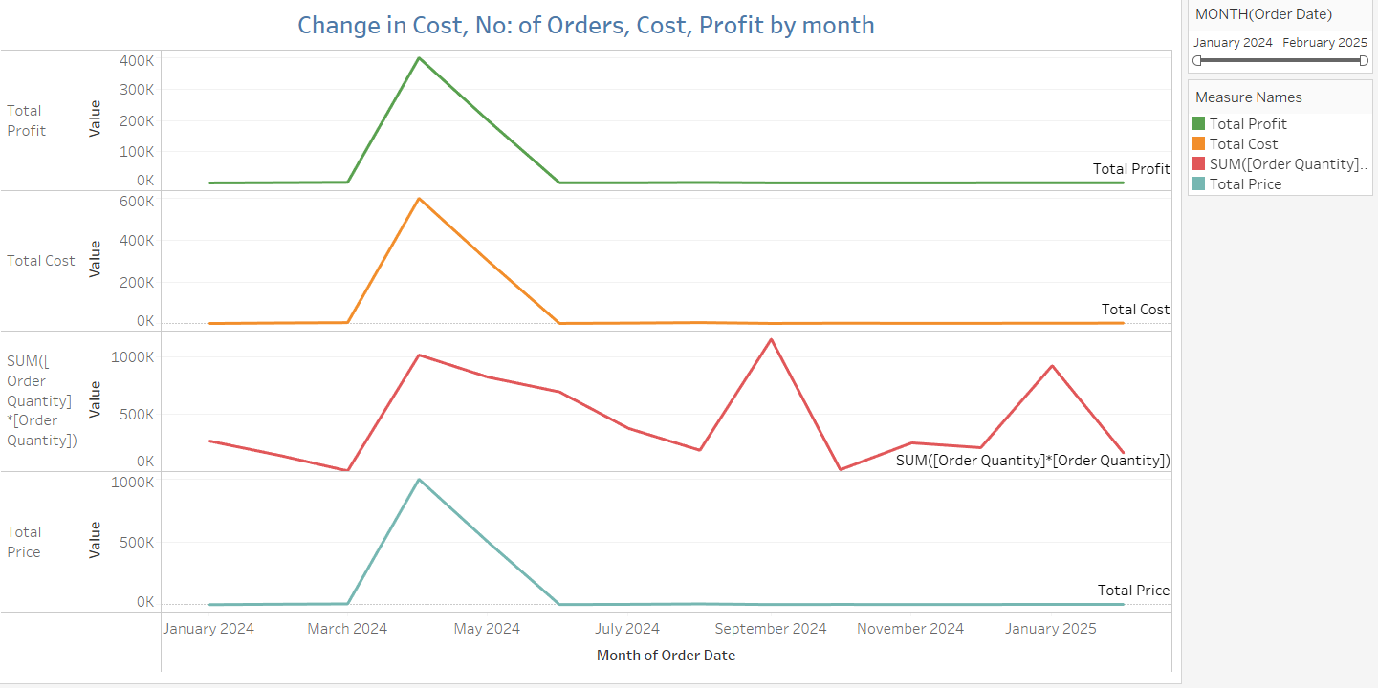
Fig 2.3

- The best & worst customers
The profit generated from the customers CU010 and CU018 is the highest. These are the best customers. The worst customers are the ones with the least profit, which are CU017.

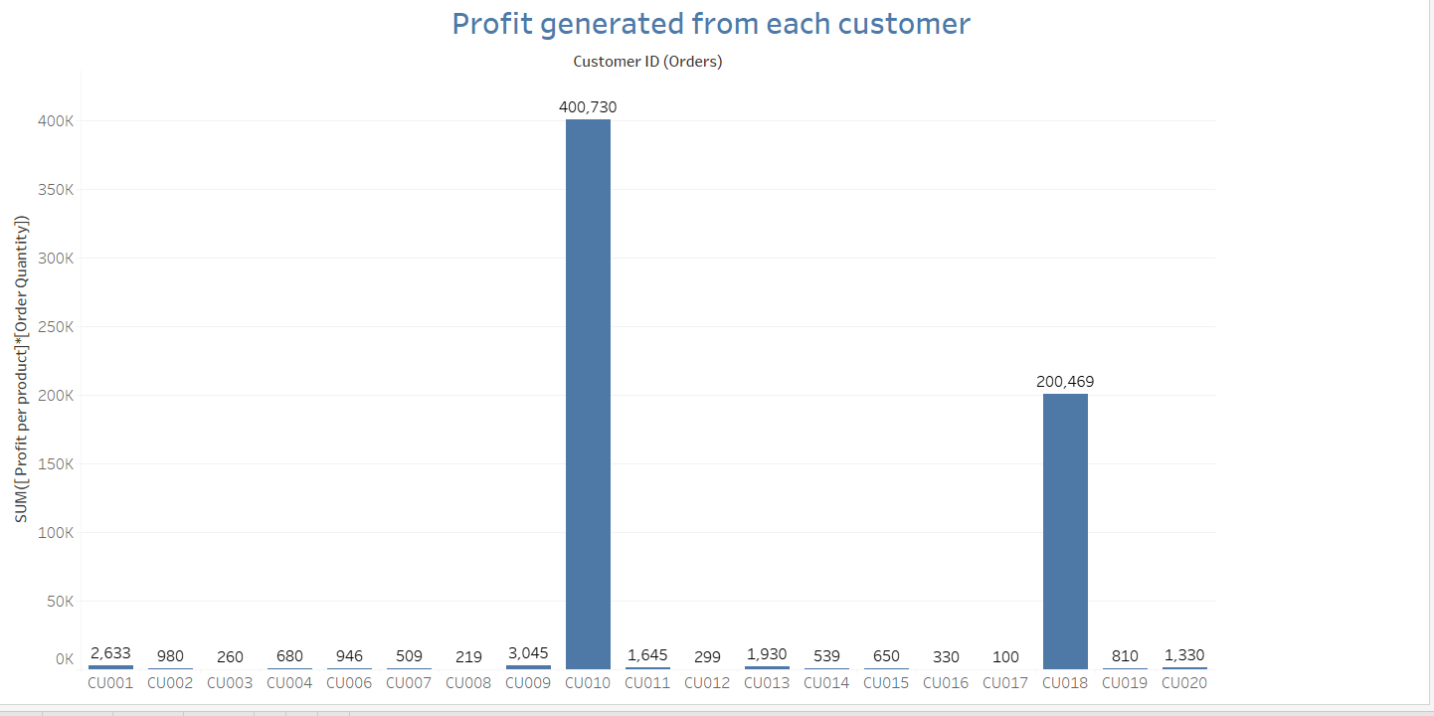
Fig 3.1
- The best area of the business to focus on
From Figure 4.1, Technology shows the highest profit while Food/Drink has the lowest. Depending on strategic goals — whether maximizing returns or improving underperforming categories — either of these could be considered the "best area" to focus on.

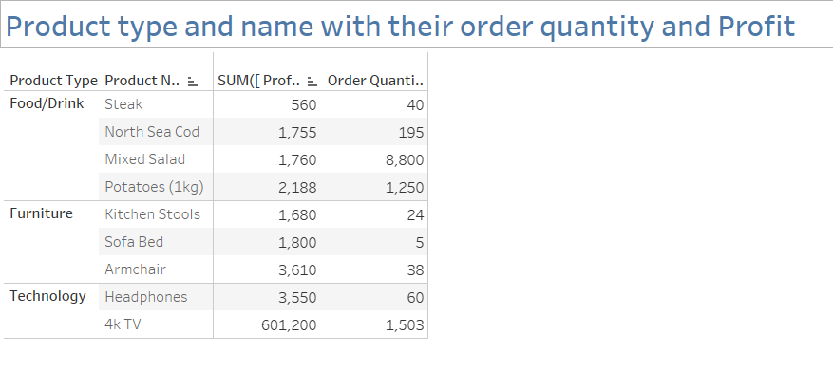Fig 4.1

- Potential area to open a new warehouse
The average shipping time is notably high in South Wales (71.6 days), West Scotland (71.67 days), and the West Midlands (50.4 days). However, the order quantities for South Wales (6 orders) and West Scotland (10 orders) are significantly lower compared to the West Midlands, which has a substantially higher order volume of 1,060 orders.

Given this disparity, the longer shipping time in the West Midlands affects a much larger customer base, making it a more critical area to address. Additionally, the West Midlands also generates the highest profit among the three regions.

Recommendation:
To improve customer satisfaction and optimize logistics, it is recommended to establish a new warehouse in or near the West Midlands. This strategic location can help reduce shipping times not only within the West Midlands but also potentially improve delivery efficiency for nearby regions such as South Wales and West Scotland.

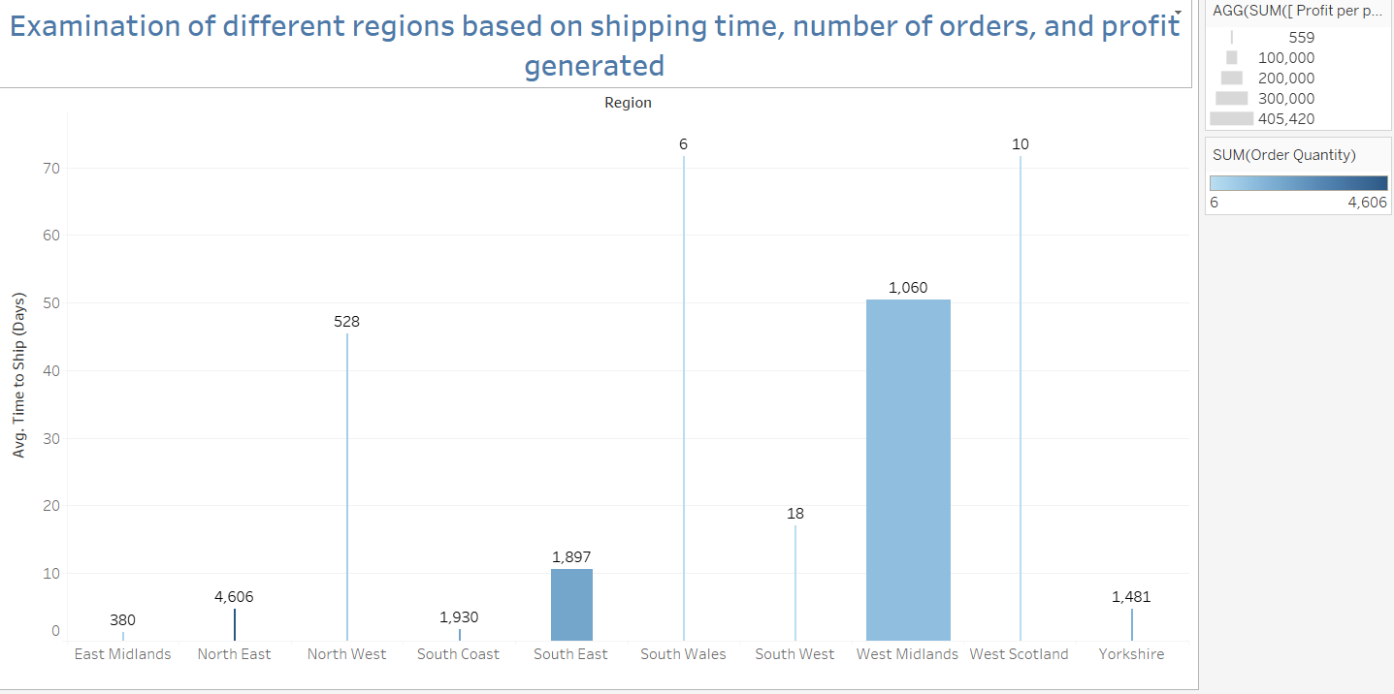
Fig 5.1

- Customers we should consider re-negotiating our contracts

Customer ID | Observation | Recommendation
CU001 | High volume, low profit | Renegotiate pricing or reduce servicing costs
CU010 | High volume, high profit | Retain and explore upsell opportunities
CU018 | Good volume, strong profit | Retain and grow further
CU009, CU014, CU006 | Mid volume, low profit | Consider renegotiation
CU017, CU003, CU012 | Very low value | Low priority or reevaluate engagement

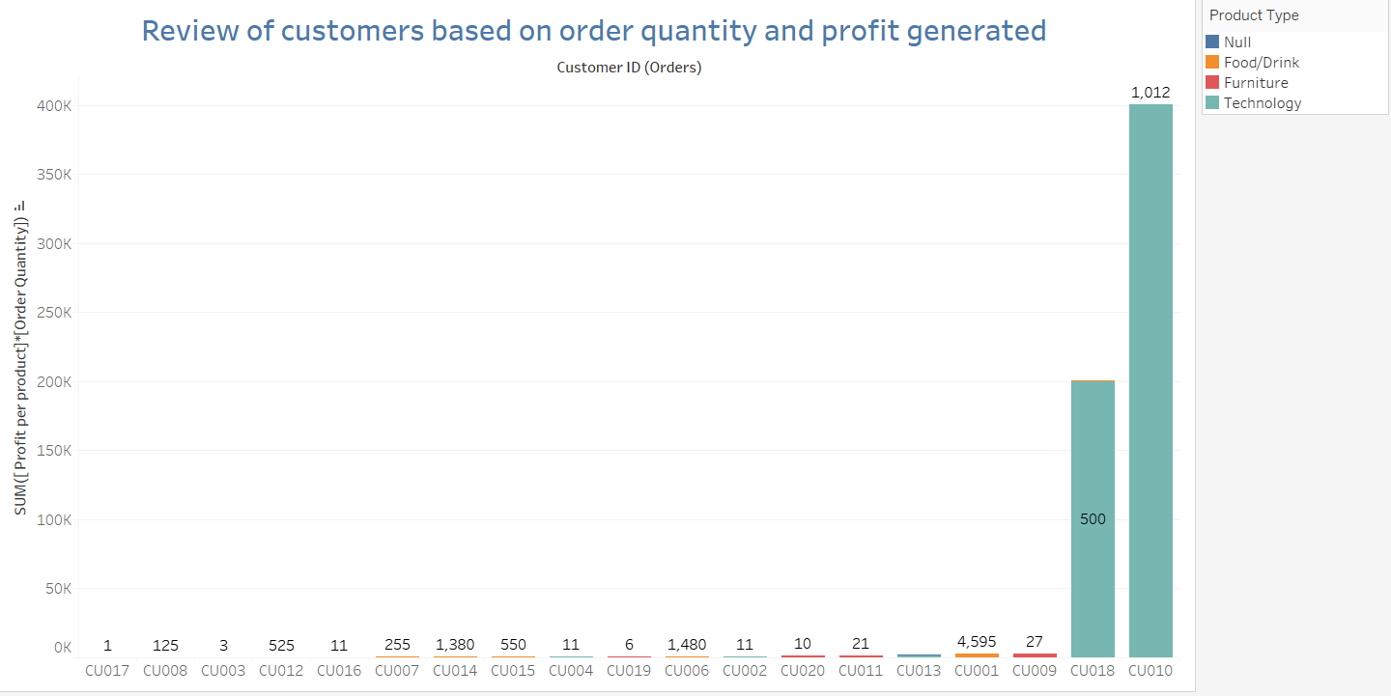
Fig 6.1

